CSCI 470/680E - Assignment 3 - Fall 2014
For this assignment, you will re-implement the Prisoner’s Dilemma Game from Assignment 2 as a Java Swing application. The GameStat and PDGame classes should remain the same as in Assignment 2.
This reusability is made possible by the power of encapsulation. All you need to write is a new version of the PDGameApp class.
Here’s a screenshot of the application’s new user interface:
It contains two major panels (additional JPanels may be nested for layout purpose). The left panel has a JList of the games that have been completed. When a game is selected, its statistics will be displayed in the corresponding JTextFields (e.g., how many rounds the game lasted, what strategy the computer used, the total sentences for the player and computer, and the winner of the game).
The right panel is for the ongoing game. It has a JButton called “Start New Game” and a JComboBox that allows you to select the computer’s strategy. It has two additional JButtons (“Remain Silent” and “Testify”) that allow the player to decide what to do each round. It also has a JTextArea to display prompts for the player and the results as the game is played.
Each JPanel should have a background color set. Recall the Color constructor: Color(int red, int green, int blue)
where the arguments are in the range 0..255 and higher numbers are lighter colors. Colors don’t have to be the same as the example screenshot. Use colors that are not too intense, and be sure that the text is legible. You will need to study how to add a Titled Border to a panel using the tutorial here:
http://docs.oracle.com/javase/tutorial/uiswing/components/border.html
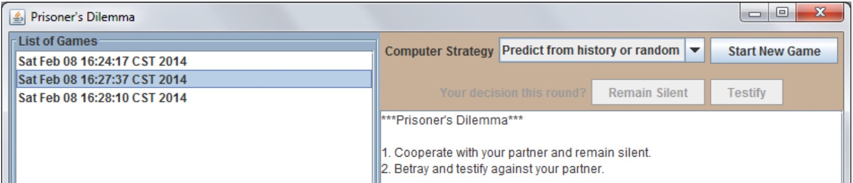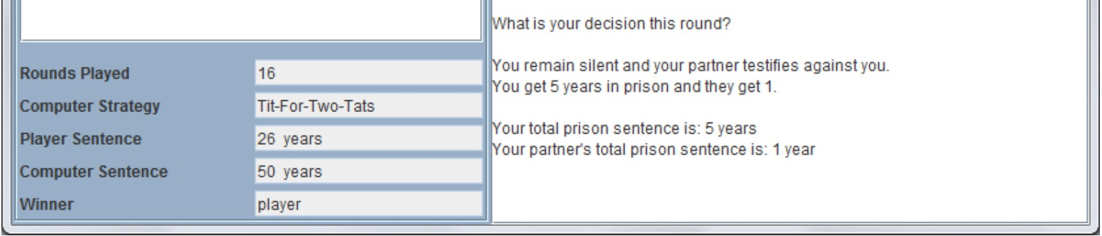
1
In this version of the program, the PDGame object and your HashMap should be data members of the PDGameApp class, rather than local variables defined in the main() function. You’ll need to create an initial PDGame object at the beginning of the program so that you can get the array of computer strategies to display in the JComboBox.
Functionality
At the beginning, the user starts by choosing a computer strategy from the JComboBox and then clicking “Start New Game”. If the user does not select a strategy, you can designate the first strategy in the array as the default (using the setSelectedIndex() method).
You will need to create a new PDGame object, and add the corresponding GameStat object to your HashMap. Prompts to the user and game results will be displayed in the JTextArea. For each round, the user will press one of two buttons, “Remain Silent” or “Testify”. Results for the round are determined as in Assignment 2. After displaying the results, the program will decide (based on a random number as before) whether to continue the game or end it. If the game continues, re-display the prompt for the user.
When the game ends, display the scores in the JTextArea. The game name for the game should also be added to the list model for the JList so the user can select it and see the results for that game.
To get a better sense of how the game is supposed to progress, take a look at the Game Play Screenshots document that accompanies this assignment.
Program Hints
You will need to use a DefaultListModel for your JList to dynamically store the game names (which are the string representations of the starting times of the games). Once an entry in the JList is selected, the game name will then be used as the key to retrieve the corresponding GameStat object in the HashMap. The getters of the GameStat can then be called to return the statistics to populate the corresponding JTextFields.
Both the JList and the JTextArea should be placed inside JScrollPanes. That will allow the user to scroll back and forth in the case of more items or text than will fit into the allowed screen space, and also ensures that the preferred sizes for those components will be respected by their layout managers.
NOTE: You can NOT use an IDE’s drag-and-drop tools to implement the GUI for this assignment.
2

